

Acknowledgement

First of all, greetings to Allah the Almighty and the most Merciful, Who give us the skill to write, to read, to learn and to complete the project. Our special praise to HOLY PROPHET MUHAMMAD (PBUH) who is forever a light of guidance we are of course solely responsible for the content in our report of “MCB HOTLINK™”.

We thank University of Central Punjab, which provides us the platform and opportunity to learn. We also thank our respectable teacher Prof. Hina Saleem, who gave her support and dedicated assistance to strive for excellent learning and appreciate coordination of Group Members to make this report more effective. And the last but not least our parents, who always remain a great source of support and encouragement who provided us the opportunity to be a part of this institute to brighten our future.

Table of Contents

Executive summary
About MCB
History Of MCB
Significant Brands
Swot Analysis
BCG Matrix
Core Distinctive Competency
Product Market Expansion Grid
Porter’s Five Forces Model
SWOT Analysis Of Mobilink
MCB Hotlink
Objectives Of Hotlink
Goals of Hotlink
Marketing Strategy
Hotlink™
Market Segmentation
Target Marketing
Market Positioning
Marketing Mix
Action Plan
Projected Budget
Projected Market Share
Evaluation And Control
Advertisement
Refrences
Conclusion

Excutive Summary

The purpose of this project was to launch new service which is available outside Pakistan but not in Pakistan yet. So, we have launched MCB HOTLINK™.

Muslim Commercial Bank is a Pakistan-based bank engaged in commercial banking and related services. The services offered by the Company include branch banking, consumer banking, electronic banking, corporate banking, and treasury and investment. Its branch banking services include direct and indirect foreign currencies remittance facility, foreign trade and correspondent banking, and safe deposit locker facilities. Through consumer banking, the Company offers credit cards, home loans, rupee traveler checks, car4u, and PayaraGhar.

Mobilink is the market leader both in terms of growth as well as having the largest subscriber base in Pakistan- a base of over 30 million and growing. Mobilink provide state-of-the-art value Added Services that no other cellular operator offers. Mobilink is a superior communications service company in Pakistan which provides the best value to its customers, employees, business partners and shareholders.

MCB has launched a service named HOTLINK™ with collaboration of Mobilink.

MCB HOTLINK™ is a service which allows customers using mobile phones to top up prepay from their MCB account, the service lets customers top up anywhere, anytime within the Pakistan while using Mobilink network.



About MCB
MCB is one of the leading banks of Pakistan with a deposit base of about Rs. 280 billion and total assets of around Rs.300 billion. Incorporated in 1947, MCB soon earned the reputation of a solid and conservative financial institution managed by expatriate executives. In 1974, MCB was nationalized along with all other private sector banks. This led to deterioration in the quality of the Bank’s loan portfolio and service quality. Eventually, MCB was privatized in 1991.
During the last fifteen years, the Bank has concentrated on growth through improving service quality, investment in technology and people, utilizing its extensive branch network, developing a large and stable deposit base and managing its non-performing loans via improved risk management processes.

History OF Muslim Commercial Bank

On 9th July 1947, Adamjee applied for registration of bank at calcutta. The license was oriented in chatagang in August 1950. First head office was established in DACCA. G.M. Adamjee was first president, H.O/ was shifted to Karachi in 1955.
Authorized capital at that time was Rs. 15,000 M as MCB was nationalized on 1st January 1974 & again it is privatized on April 1991

Vision Statement

"Challenging and Changing the Way you Bank"

Mission Statement

"MCB Bank’s team of committed professionals is dedicated to maintaining long term customer relationships through outstanding service and convenience"
Corporate Profile

Board of Directors
Mian Mohammad Mansha | Chairman
S.M.Muneer | Vice Chairman
Tariq Rafi
Shahzad Saleem
Sarmad Amin
Mian Umer Mansha
Aftab Ahmad Khan
Atif Yaseen
Dr. Muhammad Yaqub
Atif Aslam Bajwa | President / CEO

Advisor
Raza Mansha

Audit Committee
Dr. Muhammad Yaqub | Chairman
Mian Umer Mansha | Member
Aftab Ahmad Khan | Member
Mr. Tariq Rafi | Member

Chief Financial Officer
Tahir Hassan Qureshi

Company Secretary
Abdus S.Sami

Auditors
KPMG Taseer Hadi & Co | Chartered Accountants
Riaz Ahmed & Co. | Chartered Accountants

Legal Advisors
Mandiwalla & Zafar | Advocates & Legal  Consultants

Registered Office
MCB Building, F-6 / G-6, | Jinnah Avenue, Islamabad.

Principal Office
MCB Tower | I.I. Chundrigar Road, Karachi.

Registrar's and Share Registration Office
THK Associated (Pvt.) Ltd.
Shares Department, Ground Floor
Modern Motors House
Beaumont Road, Karachi

Values

Trust

We are the trustees of public funds and serve with integrity & commitment. Ethical behavior is of critical importance to us. We adopt full compliance with internal and external policies and procedures, operating within the legal framework

Customer Focus
We continuously seek to exceed our customer’s expectations, forging and maintaining long term relationships

Innovation

We strive to be the market leaders in innovative products and services offering customized financial solutions with flawless execution

Social Responsibility

As responsible citizens we contribute to the social welfare of the community we live in.

Awards And Accolades


Best Bank Award 2006

Best Bank Award 2005

Best Bank Award 2004

Best Bank Award 2003

Best Bank Award 2001

Best Domestic Bank Award 2000


Best Domestic Commercial Bank Award 2005

Best Domestic Commercial Bank Award 2004

Significant Brands

Following are the significant brands of MCB:

- 

MCB has nation's larges ATMs and still growing. it gives 24 hours convenience of cash withdrawal, mini statement, utility bill payments, funds transfer services and many more. There new mobile ATMs ensure that u r given a service closer to you

- 

MCB pyara ghar is an ideal home finance product that lets you purchase, renovate or contract your home the way you have always wanted. Financing available in up to 20 years for amount up to Rs. 20 million

-  Basic Banking Account

This product has been introduced to facilitate the low income group as well as the existing account holders who wish to convert their regular savings or current account into Basic Banking Account. The Basic Banking Account is a current account and can be opened with a minimum initial deposit of Rs. 1000/- only. There will be no minimum balance maintenance requirement, and hence no monthly account maintenance charges will apply.

- 

MCB car 4 u auto finance is your power move that gets u not only a car of your own choice but leads you to the best in life. it is affordable with competitive mark-up, flexible conditions, easy processing and above all, no hidden costs.

- 

MCB easy bill pay is an easy solution to pay your utility and mobile phone bills. MCB ATM card or MCB Smart Card holders can easily pay their bills through MCB ATM, MCB Virtual-internet banking and MCB call center with security and peace of mind.

- 

Banking at your finger tips. Sms anytime to get information regarding balance and mini statements.

- 

MCB personal loan is simply a clean facility extended out for personal use. It offers a fixed installment loan that provides you access to cash instantly without any collateral. Financing available is up to 5 years for amount up to 1 million

- 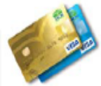

MCB Visa Cards provide convenience, safety, shopping pleasure and security giving a different feel to world of credit cards through innovative feature. These unique features include i-revolve which makes the variable markup rate available to you upon revolving and is the first of its kind in Pakistan. Other ad-ons include comprehensive insurance plans, installment plans, reward points, upfront loyalties and much more.

- 

MCB Smart Savings Account gives you the optimum value you deserve. A savings account where not only you get a competitive return but also enjoy the unlimited number of fringe benefits.

- 

Keeping in view the small savers, looking for higher returns on their savings, MCB introduces the Enhanced Savings Account (ESA). This account can be operated via all de channels available at the MCB Bank such as Cheques, Virtual Banking, Mobile Banking, MCB Smart Debit Card and ATMs/Point of Sales all across Pakistan

Swot Annlysis

Strengths
- Due to efficient and effective services MCB is become one of most profitable Bank in Pakistan.
- In the era of privatization MCB has the advantage as the first privatized bank.
- MCB has won the awards of best domestic bank from last five years. Like MCB has won two awards the EUROMONEY & the ASIA MONEY award.
- MCB is first private bank who has the largest deposits reserve. That’s why the bank has shown numerous growth for many years.
- It is honor that MCB has the maximum account holders in Pakistan it is just because of efficient customer services and trust of people on that bank.
- MCB has the significant share price in stock market.
- MCB has operating more than 926 branches all over Pakistan. This huge network of branches is one of the major strengths of this bank.
- MCB has latest technology in its processes like new software named Symbols has reduced their transaction time speedup the operations.
- MCB bank has a strong financial background.
- MCB has experienced diverse, trained, skilled professional Human resource.
- MCB is in strong competitive position.
- MCB has the widest interconnected network of ATMs.
- MCB charges less percentage of interest on advancing loans as compare to its competitors.
- Due to better services in trade MCB has become the most favorite bank for business persons.
- All the packages and schemes that MCB offered are in accordance with target market and market segmentation.
- MCB has offered wide range of products as compare to its competitors.

Weaknesses
  - Some time the performance of employees is not satisfactory because the employees are not trained. This lack of performance shows that no training sessions are held to enhance the human resources.
- The bank has still the senior staff in top level management which does not agree to come out from their comfort zone when ever the change would be implemented.
  - MCB has less staff if we compare it with the work load. This problem creates the extra burden on staff of MCB.
  - The branches in congested areas have no parking place.
  - The environment of MCB is not cooperative. There is no collectivism but individualism.
  - MCB is recently layoff their experience employees through golden shack hand scheme and that’s why employees are loosing confidence.
  - In MCB turnover rate is going high.
  - There are more than 10000 employees working in MCB so there are fewer chances of promotions for employees.
  - Employees are less motivated because all the promotions are given on referral basis not on the merit.
  - Employees are not trained to use latest technologies.
  - The division of work is not balance some braches have to do work of other branches with de motivates the employees.

Opportunities
- Banking industry in Pakistan is profitable and has high growth opportunities.
- According to the statistics of World Bank and IMF that banking sector has high growth rate in third world countries.
- MCB can capture the rural area market and also middle and low income group.
- The main sectors of our economy are now growing. There is no denying the fact that all businesses are incomplete without banking sector MCB has great opportunity.
- MCB should focus on the main sectors of our economy like industry, cottage industry, agriculture, food processing, manufacturing designing etc.
- Due to high deposits reserve MCB can expend their network work in different remote areas of Pakistan.
- MCB could create good relation ship with foreign banks and opportunity to access the foreign markets.
- MCB can utilize its large set and introduce the many better services that its competitor wont.
- MCB can launch better customer oriented schemes to capture more market share.
- Due to huge goodwill of the bank MCB can make the long term relationship with many multi national companies and provides better services to them.
- MCB can invite overseas Pakistani to invest in Pakistan and provide them better services.
Threats
- The inconsistency in government policies and instability in political setup is major threats to the bank.
- There is huge competition in the market MCB has to face because there are large number of new entrants and competitors in the market.
- No more differentiated strategy is introduced by MCB bank that caters the competition.
- Another threat is that the government is supporting the widely expanding network of domestic and foreign banks in Pakistan.
- The Muslim community is against the consumer banking.
- Foreign investors hesitate to do business with banks in Pakistan.
- Due to the brain drain there is shortage of skilled human resource.
- After the 9/11 the bad images of Muslim nations in the minds of foreign investor create the threat for all sectors
BCG Matrix
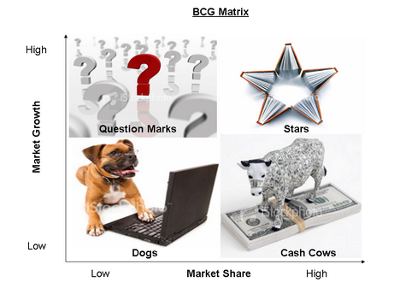

As this matrix classifies products into four classes which are stars, question marks, cash cows and dogs based on their market share and market growth rate. So we have divided MCB’s products into these four classes and are discussed below;

Stars

Products and services that have high growth rate and high market share fall in this category MCB’s services in this category are discussed below;

- ATM Services

The ATM services of MCB comes in this category because they have a high market share and a high growth rate and this is because not only MCB but other banks are also using MCB’s ATM’s services by the name of . They are using this service of MCB by obtaining a line from MCB. 75% of the ATM services of all banks are powered by

- Basic Banking Account

Basic Banking Account is a service of MCB which is meant for low income group and we all know that the population of Pakistan mainly consist of low income group and this makes this thing very obvious that the growth rate of this service is very high and market share is also very high.

- Car 4u

Car 4u comes in this category because of its flexibility, affordability, speed and because of its special benefits. Due to these features it has succeeded in capturing a high market share and high market growth rate.

Cash Cows

Products and services that have a low growth rate and high market share come in this category, MCB’s services that fall in this category are discussed below:

- Bill Payments

Because of a big branching network MCB’s bill payments service has a high market share and low growth rate because the number of customers that pay their bill through MCB varies every month. Thus they produce a lot of cash and need less investment.

- Pyara Ghar

It offers to build a new home or renovate your existing home. Its growth rate is low but market share is high.

Question Mark

This category includes products and services that have high market growth rate and low market share, MCB’s services in this category are discussed below:

- Mobilink Banking

This is a service which has a high growth rate but has a low market share because people are less aware about the usage of this service of MCB.
- Personal Loan

This service of MCB has a low market share but
high growth rate because it is a new
Product. It has a limit upto 1000,000 and does not
require any guarantor or security.
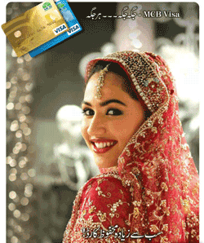

- MCB Visa

This is also a new product of MCB
and has a high growth rate but a low market
share because of its newness to the market.
Dogs

The services falling in this category have low market share and low market growth rate; MCB’s services in this category are discussed below;

- Smart Saving Account

It has good features like competitive return, unlimited fringe benefits and also the facility of being remaining connected all the time but still it has low market share and low market growth rate because it does not offer profit on amounts above 300,000.

- Enhanced Saving Account

It is meant for small investors and has low market share and low growth rate due to its slabs in profit calculation.

Core Distinctive Competency

Here we will discuss two different competencies of Muslim Commercial Bank which make it distinctive from other banks:

- The first distinctive competency that MCB offers is that they do not charge even a single paisa if a depositor of MCB withdraws cash from the ATM’s which are available at MCB branches.
- The second core distinctive competency of MCB is Global Deposit Receipt (GDR) which means that MCB is a registered company of London Stock Exchange that makes the security level of investment in MCB very high and investors feel very secure and safe while investing in Muslim commercial bank. Muslim commercial bank is the only Pakistani bank that has this distinction.

Production Market Expansion Grid

Among the four strategies of product market expansion MCB is applying two strategies which are Market penetration and Product development. The other two strategies cannot be applied to MCB in Pakistan because there is no geographical or demographic market left behind that has not been catered by MCB. However Market development can be applicable if MCB expands in other countries of the world where it is not present.

Improvement in inner and outer structure, layout, appearance and environment at the branches of MCB is an example of market penetration strategy. Another good example of market penetration strategy by MCB is opening of a mini MCB branch at fortress stadium.
Introduction of new products e.g. mobile banking, Personal loan etc. are an example of product development strategy because these are new products meant for existing markets. As, there is no market left behind in Pakistan where MCB is not pursuing its business.

The service ‘hotlink’ that we are going to launch in Pakistan also comes in the category of Product development.

Porter's Five Forces Modle

Bargaining power of MCB and Customers

Muslim Commercial bank finds itself in a very strong position when it comes to the Bargaining power of this bank because MCB is a very huge and profitable financial concern. In most of the cases the interest rate for borrowing and lending has been fixed and there is no question of bargaining. However in cases of big deposits sometimes depositors ask for higher rate of return which are agreed upon through negotiations. In such cases MCB bank offers high rate of return because it is of financial benefit for them.

No. Of Substitutes

As we all know that Pakistan’s banking industry is growing at a fast pace so there are a lot of new local and foreign banks jumping into the Pakistani market creating high competition. So there are a lot of substitutes available to any financial service in Pakistan. And same is the case with the services of MCB.

Internal Rivalry

MCB is one of the big organizations of Pakistan and in every big organizations internal rivalry, jealousy, group making, leg pulling, back stabbing exist. MCB is not any exception when it comes to these unwelcome acts.

Threat Of New Entrants

There is a very high risk of new entrants in the Pakistani banking market which all the banks in Pakistan are facing so as MCB. As it is a fast growing market so a lot of new banks are making their way into Pakistan e.g. Barclays bank has recently been issued a license by State bank of Pakistan to start its operations in Pakistan. MCB is facing a big threat from these new entrants which are no less than any global giant e.g. Dubai Islamic bank, HSBC, Barclays.



Mobilink

Mobilink GSM started operations in the year 1994, from then on it has shown enormous growth. At the time when it entered the market it was a small player in the cellular market of Pakistan, it is now the market leader both in terms of growth as well as having the largest subscriber base in Pakistan- a base of over 29 million and growing.The main head office is in Islamabad and its other offices are in Karachi and Lahore.
What makes Mobilink GSM the preferred choice of its customers is that MOBILINK provide state-of-the-art value Added Services that no other cellular operator offers. A few of these include Short Message Service (SMS), Mobilink GSM-The News Info services, Mobilink GSM G-Mail, Mobilink GSM Fax & Data Services, International Roaming, Secure Communication and Innovative tariff structures.

Mobilink Vision

“To be a superior communications service company in Pakistan which provides the best value to its customers, employees, business partners and shareholders.”
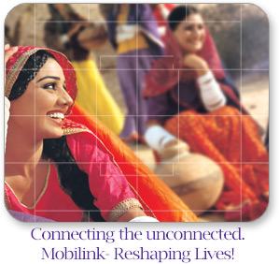

Organizational Structure And Analysis

Error: Reference source not found
GM
Customer care
GM
HR & Admin
GM
Finance
GM
Information Systems
GM
Marketing
GM
Engineering
GM
Quality Assurance
Business Unit Manager (BUM) North
BUM South
BUM Central
NOTE: Similar Lines for the other two BUMS

Brief Description

Mobilink also looks from the organizational hierarchy point of view. There are 7 different departments each headed by a General Manager. They report directly to the CEO. Then there are three BUMs (Business Unit Managers) who report directly to the CEO but they are also directed and responsible to report to all the GMs of the 7 other departments. BUMs are divided geographically into three divisions

- BUM North (Islamabad, Peshawar, Jehlum)
- BUM Central (Lahore till South of Punjab)
- BUM South (Entire Sindh)

Product Features

MOBILINK is basically dealing in two products and both of them are although same because they aim at providing connection to people but at the same time they do have different features. Now we shall consider these features in brief:

Jazz
- No daily charges

- Low outgoing rates
- 180 days validity of Jazz Scratch Cards.
These features are provided while keeping
in mind the customers, which use JAZZ cards.

MOBILINK STAR

- Low upfront cost
- Hour of free calls
- Best connectivity speed
- True International Roaming

Electronic Communication

Mobilink is providing coverage in most major cities of Pakistan
WAP (Wireless Application Protocol)
Mobilink has provided WAP services for its customers that enable them to gather information from the net. Thus connecting the people to the Internet.
SMS (Short Messaging Service)
Mobilink Sms provides you the option to stay in touch with other customers in an economical way, and you don’t even have to talk. They have also started MMS

Survey From Customers
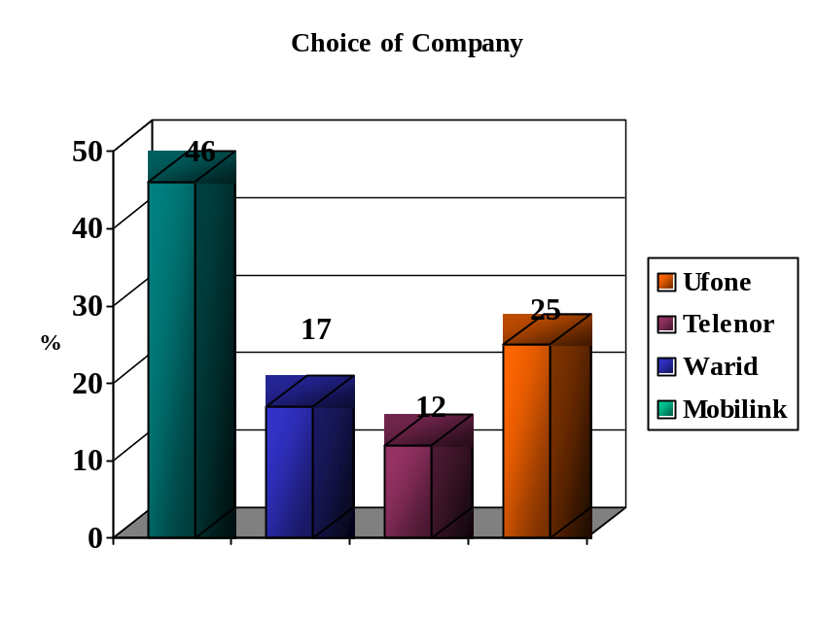According to our survey to the customers we asked them which cellular company's service they use:

The frequency distribution indicate that out of the hundred people, 46% uses the services of Mobilink, 17% uses Paktel, 12 % uses Instaphone and 25% were the customers of Ufone. This shows that the Mobilink is the most popular company amongst the cellular phone users.

Swot Analysis Of Mobilink
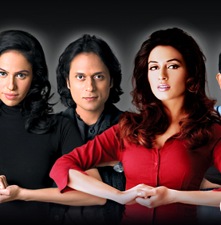

STRENGTHS

Following are the vital strengths of Mobilink:

- Mobilink is an acknowledged market leader of all the comp anies of its kind
- Being a first GSM company
- The network service of Mobilink is distributed over a wide area
- Mobilink provides good service to its customers
- The customers of Mobilink are very much satisfied therefore, it is the biggest strength
- Mobilink has a distinctive competence
- It has adequate financial resources
- The company has good competitive skills

- Mobilink has effective product innovation abilities.
- Increased brand equity
- Premium brand image
The company has hired well-qualified and able employees in all its departments.

WEAKNESSES

Following weaknesses are identified in Mobilink:

- Mobilink provides costly services to customers as compared to other mobile companies.
- Sometimes the network is busy and over loaded which results in poor connectivity.
- The product line is too narrow

OPPORTUNITIES

Mobilink has the following opportunities:

- 2.3% of the population of Pakistan is mobile users. Mobilink has the opportunity to expand its services to a larger number of people.
- Mobilink can expand its target markets and enter new market segments.
- This company has faster market growth.
- Mobilink has the opportunity to add further products to its existing product line.

THREATS

- Mobilink has two major competitors, U-fone and Instaphone. Under certain circumstances these companies may act as a major threat for the organization.
- Change in Government policies can act as a threat for Mobilink.
- Rising sales of substitute products like U-fone may also act as a threat.
- Wireless local loops can be a threat.

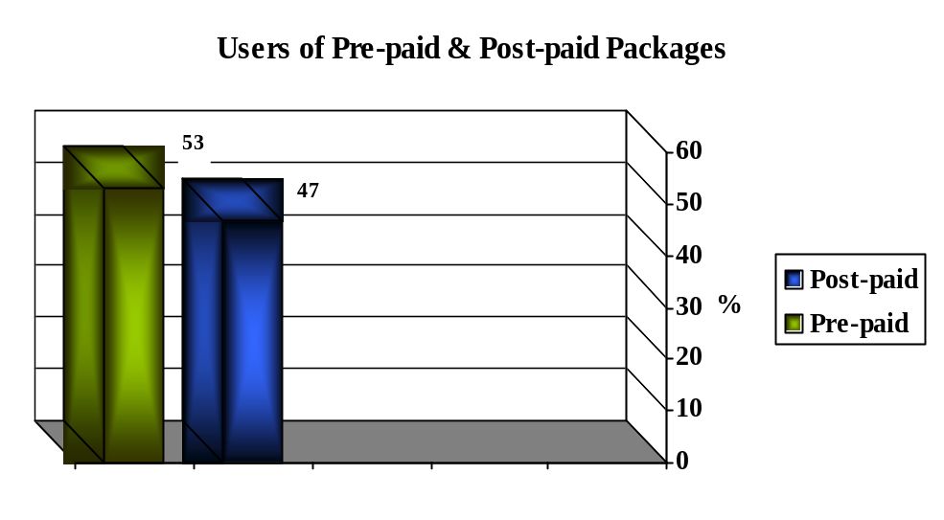
Survey Of Post-Paid And Pre-Pais Users
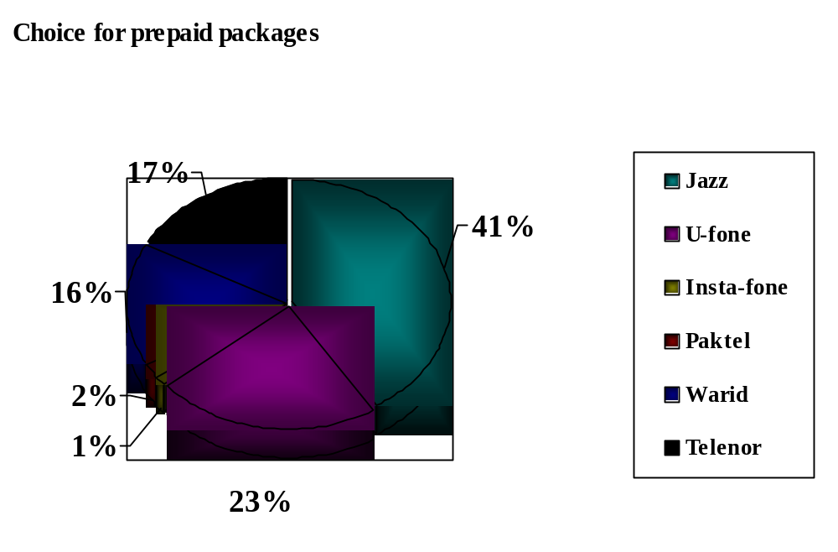 Market Share (2007)

MCB HOTLINK


It is estimated that it takes each customer an average of 10 minutes once a month to buy a Prepay recharge card.

MCB launched its HOTLINK™ service, allowing customers to use mobile phones to top up prepay from their MCB account, the service lets customers top up anywhere, anytime within the Pakistan Mobilink network.


MCB HOTLINK™ is a brand new service for all MCB customers who have a Jazz connection.

OBJECTIVE

- The objective of the HOTLINK™ is to allow the customers to pay Jazz account or top up Pre-pay balance directly from their bank account.
- Easy-to-use service that connect you to your friends, family, work, information and entertainment wherever you are and whenever you need it

- Giving a Reliable and good value added service – that’s what you care about.

GOAL
- The goal of MCB HOTLINK™ is to address more of the market, to grow the market (new users and applications), and to win more when you compete for customers.
- Winning more requires building our product offerings to target more customer needs, provide greater value than competitive offerings and offer superior return on our investments

Marketing Strategy Of Hotlink™

The marketing strategy of MCB HOTLINK is Concentrated Marketing Strategy because instead of going after a small share of a large market, MCB will go on large share of one or few submarkets. Through this marketing MCB will achieve strong market position.
On the basis of this strategy we will focus on the following points:

Positioning Strategy

Using product Concentrated Strategy; we are positioning the MCB HOTLINK™ as a most convenient, value added and easy to use service for all to use. The marketing strategy will focus on the TOP-UP through a SMS system as the main feature differentiating the MCB HOTLINK™.

Product Strategy

The features of HOTLINK™ will be described in service Review section and will be shown on MCB and MOBILINK websites and through media as well. Keeping in view that image of MCB is an integral part of product strategy; the logo will be displayed and reinforced in the introductory marketing campaigns.

Pricing Strategy

The MCB HOTLINK™ will be introduced at lower price. It reflects a strategy of capturing the whole market and taking higher market shares.

Distribution Strategy

As this service includes the ATM for registration of hotlink so we have used selective distribution strategy because HOTLINK™ can only be registered from MCB's ATMs. In support of our ATM partners MCB will provide demonstration and detailed specification on this.

Marketing Strategy

By integrating all massages in all media, we will reinforce the company image, brand name and main points of the service, especially our TOP-UP facility feature. Through advertising we will maintain product awareness and communicate various messages. The company will also coordinate public relations efforts to support the advertising messages.

Marketing Research Strategy

Using research strategy, we will identify the specific features and benefits that our target market values. Feedback from market tests, surveys will help us making this service better. The research will help us to determine the effectiveness and efficiency of our message, media and service. Finally this research will help us to know about our customer satisfaction.

How Hotlink™ Works

HOTLINK™ is a service that lets your mobile work just like your Electronic Funds Transfer Point of Sale (eftpos) card. You dial in the amount to pay, enter your eftpos PIN number-- you've topped up your Prepay balance or paid your on Account bill. Just like eftpos, the funds go direct from your bank account -- and just like eftpos, the payment is instant, so your Prepay Account balance will be juiced up right away.
You can use HOTLINK™ anytime, anywhere you have coverage -- even overseas if its on International roaming. You can make a payment on your own balance, or top up your friends' or family's mobiles.
HOTLINK™ is fast, too. Because it uses the smarts of your SIM card, there's no logging on to WAP sites or Texting back and forth. In fact, making a HOTLINK™ payment will usually be faster than sending a TXT. Imagine -- no more trips to the dairy for a recharge card. No more running out of talk time in the middle of nowhere. If you've got the money in the bank, you can power up your balance anywhere, any time.
How To Register
Put your cash card into any Muslim Commercial Bank ATM. Once you’ve entered your PIN:
- Select Other Services
- Select Mobilink Services
- Select Mobilink HOTLINK™
- Follow the step-by-step instructions to register your mobile and choose which account to use for your HOTLINK™ payments
The first time you use HOTLINK™, confirm your account by entering your ATM card's number (that’s the long number pressed into the plastic, not your PIN).

How To Use Hotlink™

Step 1: TXT your bank's name to 262
The first step is to TXT the name of your bank to 262, from your normal mobile. We'll be able to tell from your TXT if your SIM card and mobile are compatible with HOTLINK™.
Our TXT will let you know:
- You're all set to register for HOTLINK™ right now
OR
- Your mobile isn't compatible -- bummer

Step 2: Register at your Bank

Registration confirmation form Bank

Step 3: Double-confirm HOTLINK™
The first time you use HOTLINK™, you'll need to enter your ATM card number to double-confirm your identity. Once you've done that, the registration process will be complete.
NOTE You can only register one debit card per mobile connection.

How To Top-Up By Hotlink™
HOTLINK™ is incredibly easy. Once you've registered, each payment only takes a few seconds.
- Once you've registered, select the sim² "Mobilink" menu on your mobile
- Select "My Account"
- Select "Top Up/Pay Account"
- Enter the amount you want to pay
- Enter your EFTPOS card PIN number
Done! As long as you have the funds in your account, your payment will go through instantly, putting new life into your Prepay or settling your account. It's simple, it's fast and it's convenient.
Registering your mobile with HOTLINK™ is easy. You only have to do it once -- and you can start right now.
How To Top-Up Other's Account

With HOTLINK™ you can choose to purchase airtime or Top-up balance for your mates on Mobilink.
- Choose the "Other Mobile" option and
- The amount you want to Top-up
- Enter the mobile no u want to send to

Your friends will be flush in no time. Your friend will receive a TXT message advising them that you have purchased them airtime and you will also receive a confirmation TXT message

Minimum And Maximum Purchase With Hotlink™

HOTLINK™ minimum payment amounts for Prepay is Rs.20 and the maximum is Rs.1000.

Hotlink™ Transaction Confirmation

After every MCB HOTLINK™ top up you will be sent a TXT to advise that your transaction has been successful - even when you top up your mother, father, sister, brother, best friends mobile!

Hotlink™ Securities
We've ensured the security. Bank is satisfied that your account will not be at risk, even if your mobile is stolen, and we're satisfied that the security of the HOTLINK™ registration process will protect you from any fraudulent activity (if your mobile is stolen, please call MCB or Mobilink helpline straight away.)
The registration process itself requires what the banks call a "two factor authentication" -- and it does it twice, once to confirm your identity at the ATM, and another time to confirm your identity when you make your first payment.
Obviously, just as with your eftpos card, it's essential that you don not tell anyone else your PIN number. HOTLINK™ protects your PIN in several ways:
- It's much easier to enter your PIN privately on your mobile than it is at a shop counter
- Your mobile shows only **** as you enter the number, so even if someone was looking over your shoulder, they can't read it (although make sure no one's looking at the keys you're pressing!)
- Your PIN is encrypted before being sent, so it can't be read even if it could be intercepted.
Hotlink™ Terms & Conditions
- To register for HOTLINK™ you must visit an ATM of Muslim Commercial Bank and follow the on-screen prompts. For security reasons you may only register one debit card on your mobile phones SIM card for HOTLINK™ and that debit card cannot be registered for HOTLINK™ on another SIM card.
- You will be responsible for these charges. Where you choose to make a Payment to your mobile phone using HOTLINK™, the Payment will be made to your Mobilink account.
- The HOTLINK™ service will at all times be subject to Mobilink network coverage. HOTLINK™ is only available to mobiles that are able to send text messages, have the correct SIM card version, and are compatible with the HOTLINK™ service.
- Outside Pakistan HOTLINK™ is available to you subject to network coverage and terms and conditions. For more information about roaming coverage, please contact Mobilink Customer Services.
- On successfully making a Payment using HOTLINK™ your mobile phone will receive a text message confirming this. The Payment will not be complete until you receive this message. You can, however, check with Customer Services to find out whether your Payment has been successful.
- It is your responsibility to ensure that you enter the correct mobile phone number when making a Payment to another mobile phone using HOTLINK™. We will not be responsible for any inaccuracy in your instructions and will not be required to refund to you any Payment you make by mistake. We do, however, reserve the right to deduct from your Mobilink account any Payment that is mistakenly paid to you.
- when you make a Payment using HOTLINK™ you must enter the PIN number from your debit card, not your Mobilink PIN number. You must keep the PIN number from your debit card confidential at all times in accordance with your MCB terms and conditions. If the incorrect PIN number is entered more than once bank may block your debit card. If this occurs you will need to contact bank. In these cases Customer Services may direct you to contact your bank about HOTLINK™.
- We can, at our discretion, impose limits on the amount of any Payment you can make using HOTLINK™. You must observe any limits we set from time to time although we will not be liable to you should we allow you to exceed these limits.
- To the extent permitted by law and without limiting any other provision of this Agreement, we will not be responsible for any direct or indirect loss or damage you suffer that results from your use of HOTLINK™, your inability to access HOTLINK™, any delay or failure in processing any Payment using HOTLINK™, or any act or omission of any third part
Hotlink™ Action Plan

Following worksheet(1st year) provides an overview of MCB Marketing & overall Management Planning team’s timeline of all the strategic activities, which will be implemented as per schedule, in launching new service “Hotlink” with the co-operation of Mobilink.

Establish a Time Line of Strategic activities

Activity | Start Date | Target End Date
Form a team | 1-3-2008 | 1-3-2009
Assess target audiences and their needs | 1-3-2008 | 1-3-2009
Vision and Mission | 1-3-2008 | 1-3-2009
Strategic Goals andObjectives | 1-3-2008 | 1-3-2009
Keys strategies to achieve goals | 1-3-2008 | 1-3-2009
Keys strategies to achieve goals:

- Promotional strategy
- Advertising strategy
- Launching strategy
- Control strategy
- Evaluation analysis strategy

Following are described one by one.

From a team

Who needs to be involved? (eg. staff , board members, volunteers)

Name and Role | Assigned Tasks
Chief Financial Officer | Lead and coordinate strategic marketing planning process
General Manager Marketing | Lead and coordinate strategic marketing planning process
General Manager Control and Operations | Lead and coordinate strategic marketing planning process
Manager Audit | Lead and coordinate strategic marketing planning process
General Manager Planning | Lead and coordinate strategic marketing planning process
General Manager Information & Technology | Lead and coordinate strategic marketing planning process

Assessing Target Audiences

Take a look at the groups of people MCB wants to serve and what they need

Target audiences | Needs of theirs that we can fulfil
53% & 47% users of pre-paid & post paid customers. | They need that type of service which can lead to instant recharge/pay their accounts/bills.
41% market share of Mobilink jazz | People really want that type of service through which they can upload or top-up their mobile usage account, what they desire conveniently and instantly.  - Specially for theses people  - less time for purchase new recharge cards  - new technology lovers  - easy access every time, everywhere in world

Vision and Mission

Mission/Vision | Desired outcomes
“MCB Bank’s team of committed professionals is dedicated to maintaining long term customer relationships through outstanding service and convenience.” | - Provide exceptional service of prepaid recharge and post-paid paying the bills having competitive edge with strong network of Mobilink.  - To ensure the target audiences about 100% satisfaction by MCB bank limited.

Strategic Goals and Objectives

Non-Financial  To achieve highest level of satisfaction in relation to new service provided | Key strategy  Concentrated Marketing Strategy
Financial  Primary financial goal of this service is to increase market share by 2% p.a. over 5 years plan. | Concentrated Marketing Strategy

Keys Strategies To Achieve Goals

Strategy | Action | Who is Responsible | When | Anticipated Result | Actual Result
Promotional strategy | Special events  Presentations  Networking  Press kits  Public service announcements (PSA)s | GENERAL MANAGER ADVERTISING&PROMOTION | 2008  1 MARCH  1 APRIL  1 MAY  4 JUNE | PREPAID AND POST PAID USERS ATTENTION UP TO  30 TO 40 PERCENT
Advertising strategy | Direct mail  E-mail messages  Magazines  Newsletters  Newspapers (major)  Posters and bulletin boards  Radio announcements  Television ads | GENERAL MANAGER ADVERTISING&PROMOTION  MANAGER  ADVERTISING&PROMOTION | 2008  1 MARCH  3 APRIL  16 MAY  27 JUNE  29 JULY  11 AGUST | REACH MAXIMUM TARGET PREPAID AND POSTPAID CUSTOMERS 80 TO 90 PERCENT
Launching strategy | Hotlink will be introduced at mobilink telecom line. | GENERAL MANEGER  INFORMATION AND TELECOM ENGINEERING | 2008  24 MARCH | FULL SATISFIED TO THE EXPECTED TARGET CUSTOMERS
Control strategy | Control the infrastructure  Measure the results  Customer complaints if  Take action measures  Observe total quality management (TQM) | GENEREAL MANEGER  CONTROL AND CONSTUCTION | 2008  30 MARCH  27 JUNE  18 JULY  27 AUGUST  23 SEP  18 0ct  27 dec  2 jan  1 mar | TO COMPLIANCE THE MISSION STATEMENT  100% SATISFACTION OF CUSTOMERS
Evaluation analysis strategy | Evaluations on expecting sales and market share | GENERAL MANEGER  FINANCE | START2008  AFTER EVERY 3 MONTHS | TO MEET THE EXPECTED REVENUE AND MARKET SHARE

Projected Budget For One Year

Initial Costs &Capital Costs

Technology infrastructure (servers) | RS. 10,000,00
Installation | RS.20,000
Insurance premium | RS.12,000
Printing and artwork | RS.2,000
Initial promotion | RS.20,000
Promotional cost | RS.35,000
Computer software | RS.25,000
Training | RS.20,000
Statutory charges (licences, permits and registrations) | RS.5,000
Subscriptions for publications | RS.2,000
Total: | RS.11,41,000

Possible overhead expenses for the first year

Rent | RS 14,400
Salaries | RS 1,00,000
Misc.expenses | RS 7,000
Advertising | RS 1,20,000
Insurance payments | RS 25,00
Accounting fees | RS 5,500
Electricity and gas | RS 20,000
Entertainment | RS 10,000
Total: | RS 3,01,900

Total budget S. 1442900

Total estimated revenue
Projected revenue of hotlink service is being predicted on the basis of demand of one year and it is as follows.

Total Customers = 4, 000, 00
Per message cost = RS. 2.00
Total revenue = RS 8, 00,000

Total life 5 years

Projected Profit Margin

Our projected profit margin for hotlink service will be in first year as follows.

Total revenue RS 8, 00,000
Operating expenses RS 2, 00,000
(Infrastructure expense is being allocated)
Initial expenses = RS 1,41,000
Other expenses RS. 3, 01,900
Net profit RS 1,57,100

Projected Market Share

As MCB’s market share for 2006 is 9%, so upon launch this service its share will be increased by 2% p.a.

Evaluation And Contrl

MCB bank limited has pride itself on high levels of control and evaluation methods. These have been depicted by MCB in extensive quality control, risk analysis and evaluation.

Quality control

It is an on going process for MCB control management department to ensure total quality management (TQM) of MOBILINK service infrastructure.
MCB works in accordance with statutory regulations in order to meet IBP standards. Such standards will be met through proper checking at different times as per schedule during 1year leading to 5 years for 100% accuracy in design, functions and technical features. Through audits, team leaders and management staff will document progress in order to continually improve quality of all production.

Risk analysis

Mobilink employs 24hr security systems to ensure the technology infrastructure. Mobilink will also have insurance on equipment.
Furthermore, if malfunctions occur within the machinery, it will automatically close down itself to ensure the safety of employee.
IN All, above all the risk factor that might exist will continually be observed by MCB control & management.

Evaluation analysis

MCB evaluations will be based primarily on meeting sales and market share expectations as described earlier. MCB will be conducting sales analysis every 6 months and adjusting the promotion budget accordingly.

Market Segmentation

There are different ways of segmenting the market. People who have account in banks and are using different cellular services are basically divided into following segments.

- Pragmatists
- Technology Adopters
- Favorable
- Critics

Pragmatists:

This group is distinct from the others by being defined more by basic issues of bank functionality and limited financial sophistication. Its constituents are:
- Least likely to say they research before making a top up decision;
- Least likely to consider themselves a knowledgeable customer
- Least comfortable using an alternative method to obtain top up facility.
On most attitudinal statements, they are "somewhat favorable," with few strong
Opinions. Other attributes of Pragmatists include the following:
- They have a somewhat lower educational profile, and are marginally less
Likely to be single than consumers overall;
- Females make up 60% of this group
Technology Adopters:
These consumers are defined by their attitudes towards technology. They are:
- Most comfortable using an alternative method, such as an ATM, a computer,
or the telephone to obtain top up facility
- Somewhat critical of the technological sophistication of this service
- Least likely to say that procedural terminology is often confusing to them.

Examining demographic and other characteristics, we see that this group:
- Is somewhat more likely to use a credit and ATM cards
- Has a considerably higher educational attainment than consumers overall
- Is much more likely to be employed full-time.
- They like new ways for top up their mobile account.
Favorable:

This group represents the most favorable segment in terms of its attitude towards banks and cellular service. These consumers are the most likely to agree that:

- Banks cares about their customers
- It always explain their services in a way that is easy to understand
- It is committed to meeting needs of customers.

Critics:
This group, the smallest market segment, is the most critical of the banking industry. They are the least likely to agree that:
- Banks explain their services in a way that is easy to understand;
- Banks are committed to meeting financial and other needs of customers
- Banks are supportive of small business in their communities
- Banks are flexible in meeting financial needs;
Multiple Segmentation
For launching this service MCB is not limiting its segmentation analysis to only one or few variables .Rather, we are increasingly using multiple segmentation bases in an effort to identify better defined target groups.
Target Marketing
A market coverage strategy for this service is Concentrated Marketing because instead after a small share of a large market, MCB will on large share of one or few submarkets. Thought this marketing MCB will achieve strong market position in the segments it serves because of its greater knowledge of the segments needs and the special reputation it acquires. And it enjoys many operating economics because of specialization production, distribution, and promotion
- This service is helpful for middle to upper income professionals like doctors, teachers, and lawyers etc who need such type of service to co-ordinate their busy schedules and communicate with family and colleagues.
- Moreover we are also targeting universities and college students who need this service for different purposes .This segment can be described demographically by (16-30)
- We are also targeting mid to large sized corporations that want to help their managers and employees stay in touch and share important information.
- Furthermore, we are also targeting entrepreneurs and small business owners.
Market Positioning
MCB is going to position HOTLINK™ as the most simple, easy and convenient method to top up your mobile. With HOTLINK™ you can top up anywhere and you can use your prepaid mobile phone anytime of the day, seven days a week. It's the easiest way to top up your mobile, straight from your bank account.
It's a useful service if you want to top up your children's phone or top up your own phone credit while abroad. It is a lower-cost method of adding credit than vouchers. The service is available 24 hours a day*, every day plus
- you can top-up your own, a family member or friends mobile phone
- all Mobilink user can use this who have account in MCB
- you can top up your account by any amount
- it's a secure top up facility
Marketink Mix
The marketing mix is consists of every thing that can influence the demand for the service. so the “Seven p's” are:
Product:
It is a service which is use to facilitate the top up of mobile in easy way. It can be categorize as a convenience service that customer usually buy for use.
Price:
For this service MCB is using Penetration Pricing strategy. The price charged for this service is very low in order to gain market share. It will charge you only the cost of single text message.
Place:
Place is also known as channel, distribution, or intermediary. The mechanism through which this service can reach to its customers is that they should have account in MCB and should possess ATM card moreover, they have the connection of Jazz. All they have to do is that they have to send a text message.
Promotion:
MCB is trying to promote this service by informing his existing customer by sending them letters, brochures, internet, mails and by giving pages to customer containing full demonstration of HOTLINK™. It includes building an identity for the corporation and brand, managing advertising campaigns, sponsorships (example: the concert) and through brand ambassador, media relations (newspaper coverage, press releases, press conference before launching etc), point of sale material preparation (brochures, tariffs, flyers etc), website management to attract new customers as well.

People:
This service is convenient for every person irrespective of demographic and behaviorally basis .People belonging to different occupation and gender can use this Hotlink .It is also very cheap and save valuable time of people
Procedure:
You can easily top up your mobile by this service by a very simple process.
- Once you've registered, select the sim² "Mobilink" menu on your mobile
- Select "My Account"
- Select "Top Up/Pay Account"
- Enter the amount you want to pay
- Enter your EFTPOS card PIN number
It will debit the required amount from your account and credited to your mobile
Physical evidence:
Physical evidence is the material part of a service. Strictly speaking there are no physical attributes to a service, so a consumer tends to rely on material cues. There are many examples of physical evidence, including some of the following:
- ATM
- DEBIT CARD
- MOBILE
- SIM CARD
Advertisement
Hotlink Advertisement campaign consist of different modes of Advertisement Techniques Includes
TV and Radio Commercials:
The TV Commercial is generally considered the most effective mass-marketing format, different celebrities of Pakistan will be engaged in different TV and Radio commercials to promote HOTINK, as Mobilink current celebrities are film star Shan, Modal Iman Ali and many other. Virtual advertisement may be inserted into regular television programming through computer graphics.
Print Media
In print media we will have attractively composed adds in top five news papers and magazines of Pakistan like:
- Jang
- The News
- Dawn
- Akhbar-e-Jahan
- Mag
And many other famous new papers and magazines as well.
Billboards
Eye catching billboards are to be assembled at the most prominent and posh areas of Pakistan to attract the customers, MCB HOTLINK will be printed on popular buses traveling within the metro cities and also on the busy bus stops.
Brochures
Bulk brochures will be distributed containing details about the HOTLINK service including Benefits, complete procedure to use etc.

Electronic Advertisement
Advertising on the World Wide Web and email is a recent phenomenon which includes: web banners, web popup, Specialized HOTLINK web banners and web popup will be placed on top websites used in Pakistan to capture more Public attention. The will also be available on MCB and Mobilink official web sites
Public Events
Different musical shows and entertainment activities e.g. Cricket Tournament will be arranged and sponsored by the company to advertise HOTLINK and the event tickets will also be used to convey the HOTLINK services.
Conclusion

We have concluded that the service of HOTLINK™ will be successful and valuable service in Pakistan because the ratio of prepaid users is greater then the post paid and there is a high rate of prepaid users who have debit card also. MCB is one of the leading bank in Pakistan this service will help them to increase the market share, growth rate, and strengthen their position in market. Initially this service is being launched with collaboration of Mobilink; in the long run MCB is interested to make agreements with other cellular companies also , So that different cellular uses can easily get benefits from this service. It will help MCB to make a strong goodwill in the market and to increase its customer equity.

Refrences

www.mcb.com.pk

www.Vodafone.com/hotlink

www.mobilinkgsm.com

www.google.com

www.yahoo.com

